Practical Week-6
Task 1: Create a client-server application using Named Pipes (FIFOs). The client sends messages and the server processes and responds to them. Analyze FIFO behavior when multiple clients communicate simultaneously.
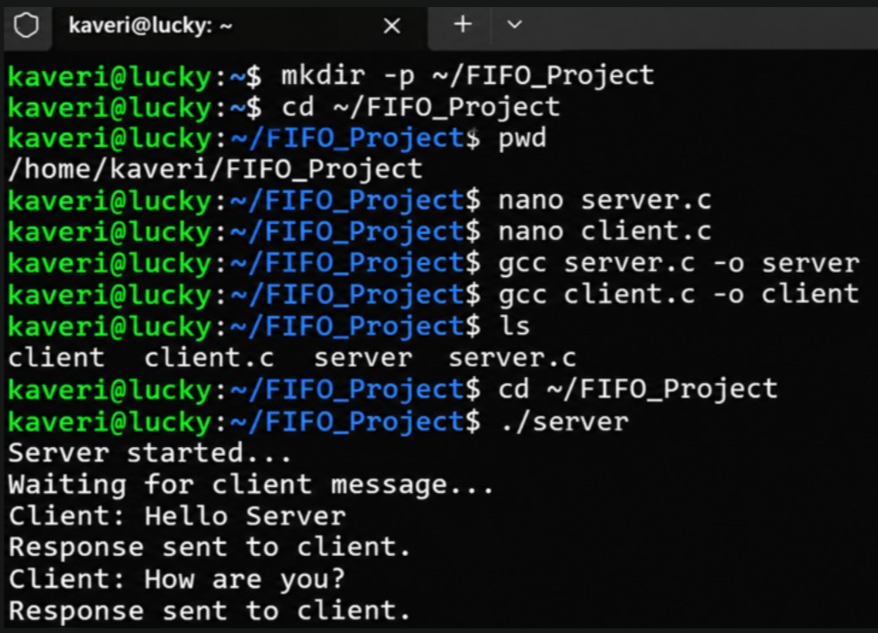
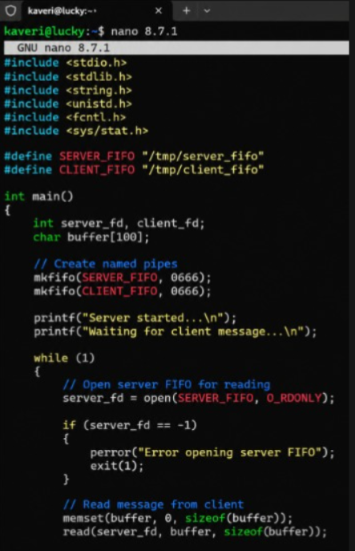
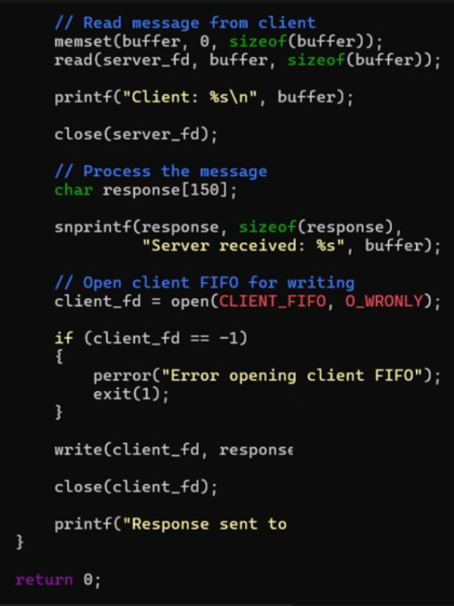
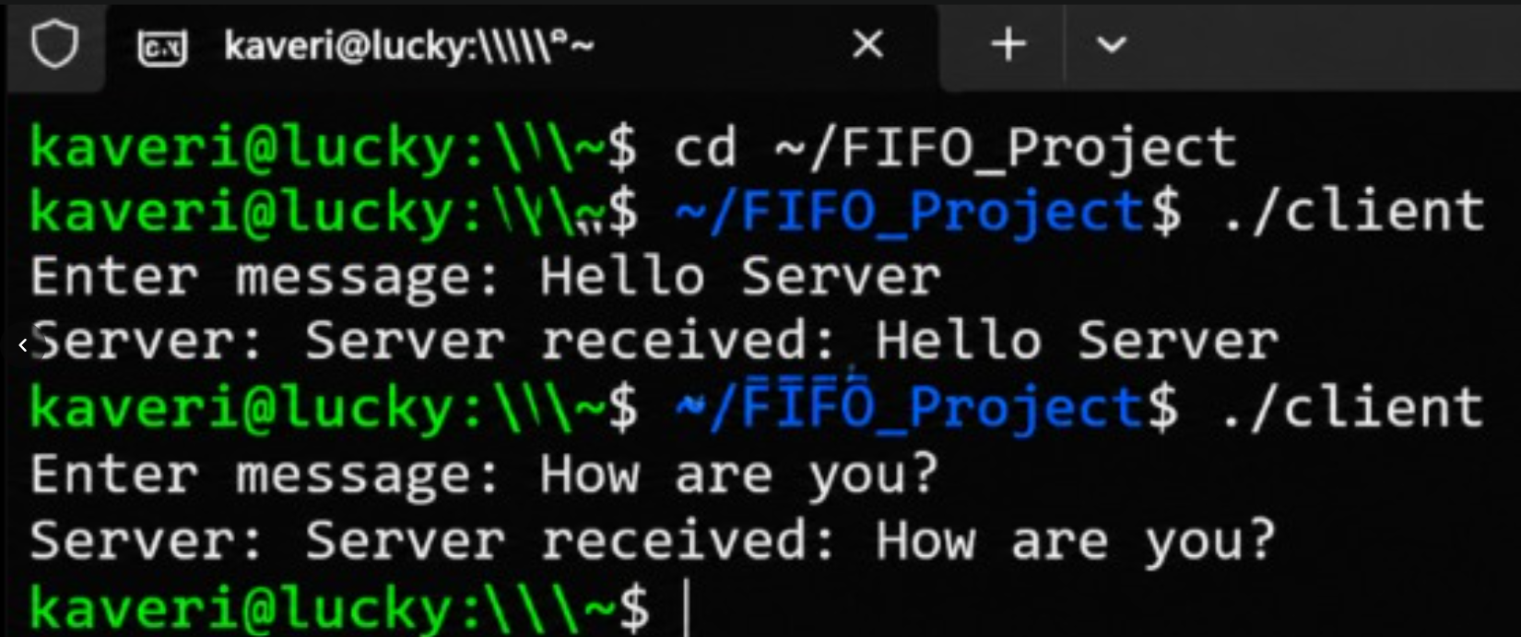
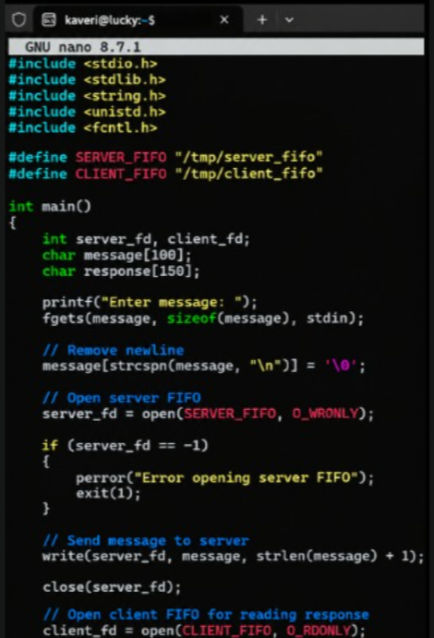
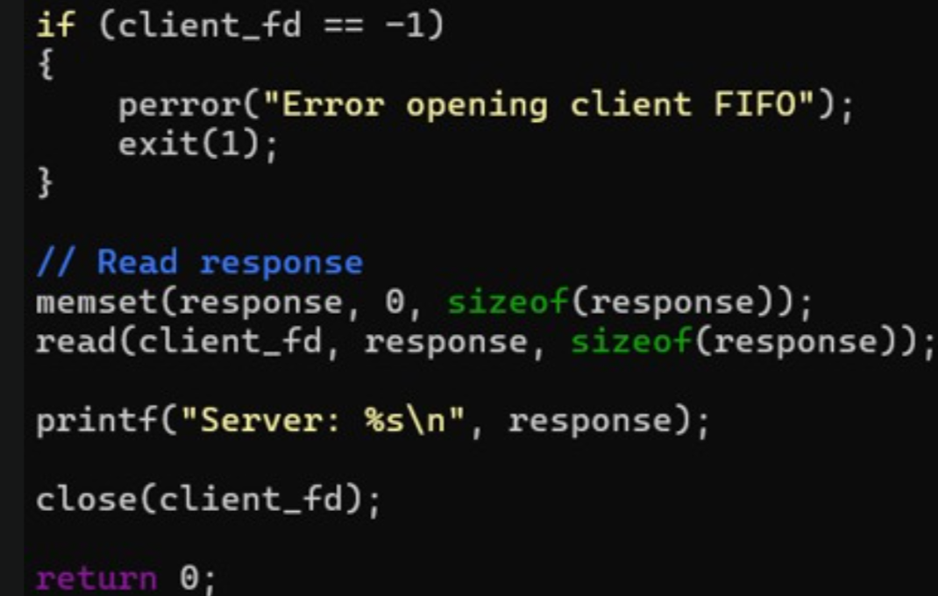
Task 2: Create a POSIX signal handling program that captures SIGINT, SIGTERM, and SIGUSR1. Demonstrate asynchronous event handling and explain the role of signal handlers.
